A

**MAJOR PROJECT**

On

=== LIBRARY MANAGEMENT SYSTEM ===

Submitted for partial fulfillment of requirement for the award of

Degree

Of

**Bachelor of Computer Application**

Of

**CHAUDHARY CHARAN SINGH UNIVERSITY, MEERUT**

**Session 15-2018**

Supervised by: Submitted by:

ASST.PROF. NARESH KUMAR

RuchiSrivastava Roll N:-1587909037

BCA VI SEMESTER



Hierank Business School

A – 42, Institutional Area, Sector – 62, Noida

**DECLARATION**

I the undersigned solemnly declare that the Major Project entitled

“LIBRARY MANAGEMENT SYSTEM” is based on my own work carried out during the course of my study under the supervision and guidance of **RuchiSrivastava.**

I declare that the statements made and conclusions drawn are an outcome of my Project Work. I further declare that to the best of my knowledge and belief the Project Report does not contain any part/work which has been submitted for the award of any other degree/diploma/certificate in this University or any other University.

**Name of Student :-NareshKumar**

**Roll No. :- 1587909037**

**CERTIFICATE BY GUIDE**

This to certify that the Major Project entitled “LIBRARY MANAGEMENT SYSTEM ” carried out by **Naresh Kumar** bearing Roll No.: **1587909037** and Enrollment No.:-**M15633993** under my supervision and guidance for the partial fulfillment of Degree in Bachelor of Computer Application of ChaudharyCharan Singh University, Meerut.

To the best of my knowledge and belief, the Report:

* embodies the work of the candidate,
* has duly been completed,
* meets the desired standards for the purpose of which it is submitted.

**RuchiSrivastava**

**Assistant Professor –IT**

**Hierank Business School**

**A – 42, Institutional Area,Sector -62, Noida**

*The Major Project Work as mentioned above is hereby recommended and forwarded for examination and evaluation.*

**ACKNOWLEDGEMENTS**

I would like to take this opportunity to express my sincerest gratitude to all the people without whom the project would not have been a success. To begin i would like to express my deep felt gratitude to **RuchiSrivastava**

for providing me with invaluable guidance from time to time.

I would also like to thank all the faculty members for the wonderful working environment that i had the pleasure of working in.

I am highly indebted to **RuchiSrivastava** (Asst.Prof. , HBS) whose able guidance and constant feedback inspired me to improve my skills at every stage. Without his invaluable expertise, insightful input and constructive criticism, the major project would not have been taken its present shape.

Name of Student:-**Naresh Kumar**

Roll No.:- 1587909037

**INDEX**

|  |  |  |
| --- | --- | --- |
| **S.N.** | **TOPIC** Designing | **P.N.** |
| **1** | **Introduction** | **6** |
| **2** | **Abstract** | **7** |
| **3** | **Objective** | **8** |
| **4** | **Scope of Project** | **9** |
| **5** | **Hardware Requirements** | **10** |
| **6** | **Software Requirements** | **10** |
| **7** | **Introduction of visual basic and Ms access** | **11** |
| **8** | **DFD,ER diagram** | **14** |
| **9** | **Model** | **16** |
| **10** | **Designing** | **19** |
| **11** | **Testing** | **33** |
| **12** | **Screen short** | **35** |
| **13** | **Source code** | **40** |
| **14** | **Conclusion** | **48** |
| **15** | **Future application of project** | **49** |
| **16** | **Bibliography** | **50** |
|  |  |  |
|  |  |  |

**Introduction of library management system**

This development “LIBRARYMANAGEMENT SYSTEM” aims at

Automates each and every one the work being done manually in library at present. On completion this project would expedite the work in all regard. Some of the facial appearance of this software would be:

Creating arrangement to automate the armed forces offered by the collection, this would be more flexible than their earlier system. The features include

1. Storing, editing and reporting Staff Details.

2. Storing, editing and reporting details of all the books available in q the library.

3. Managing details of student ‘signing in & out of the library.

The present epoch is given to the Information technology. I.T. is a new and fresh integrated approach and a key to unlock all the intricate problems of our modern era. This technology tends to cater all our needs. It is not only an ‘Integrated Approach’, but also job-oriented & concrete device to aware us of the up-to-date skill and knowledge. It has worked a magic wand in the spheres of industry, medicine, engineering, agriculture, transportation, electronics & electrical devices. I.T has boosted progress beyond description. It has given us the safest & the most concrete means of instruction i.e. computer, Internet, E-mail, E-commerce, Website and a lifeline for most of our problems. I.T has to a larger extent, played a role in bettering the global economy. Although there are many institutes offering these services but still quality work is always in demand.

**Abstract**

This report describes the project development of Library Management System that was developed to manage the daily book transaction and manage the member, books record more efficiently. It can improve management of the book property in the library.

This Library management system is mainly use by librarian and library admin. Normal librarian is able to manage the member maintenance module, book maintenance module and also the most important module in a library which is book transaction module. Besides that, library management system also allows user to manage the publisher as well as lost book module. On the other hand, other type of user which is admin level staff is able to handle the staff module and view the report module.

The methodology I used to develop this system is waterfall model. Thus, the report’s chapter was included system planning, requirement analysis, system design, programming, system testing, and evaluation of the project. For the system planning, the outcome is the project objective and project aims as well to define the project scope. Requirement analysis is a stage to gather the user requirement such as functional requirement. Next, the system design is mainly used to user interface and database design. The next stage after system design is programming stage.This is the stage for coding. After complete coding part, we proceed to system testing to minimize the system bug. Compare to the existing library system, this system has some strength and weaknesses compare to other such as lack of smart card technology. In the future, we can enhance the system with smart card technology to make it more perfect.

**Objective**

* Improvement in control and performance the system is developed to cope up with the current issues and problems of library the system can add user, validate user and is also bug free.
* Save cost

After computerized system is implemented less human force will be required to maintain the library thus reducing the overall cost.

* Save time

Librarian is able to search record by using few clicks of mouse and few search keywords thus saving his valuable time**.**

* To build a system that can receive input and generate automatically output in easy way and short time.
* To build a monitoring system that is able to monitor and manage all library operations efficiently.
* Give an opportunity to librarians to reduce mistakes that always happen during manual method.
* To store properly the library items in order to maintain their security.
* To enter and preserve details of the various issues and keep a track on their returns.
* This system basically has four types of modules that handle daily activities for the library :
* Manage Account module
* Search Record Module
* Book Borrowing System Module

**Scope**

The scope of this project is as follows:

To assist the staff in capturing the effort spent on their respective working areas.

1. To utilize resources in an efficient manner by increasing their productivity through automation.
2. The system generates types of information scopes behind developing the “**Library management system**” and it reduces a lot of burden of the entry.

**Future scope**

This application provides a computerized version of library management system which will benefit the students as the staff of the library.

It makes entire processes where student can search books, staff can generate reports and do book transactions.

There is a future scope of facility that many more feature such as lecture video tutorials can be added. We can add previous year question paper for students.

We can add a monitoring panel using of this panel we can track our books.

**Operation Environment**

* Hardware requirements

|  |  |
| --- | --- |
| Processor | Intel Pentium 4 or higher |
| Memory | 1Gb or higher |
| Hard disk space | 500 MB or higher |

* Software requirements

|  |  |
| --- | --- |
| Operating system | Windows 7 |
| Windows framework | 4.62 or higher |

**Front-end or Back-end**

|  |  |
| --- | --- |
| Back-end | Ms Access |
| Front-end | Visual Basic |

**VISUAL BASIC**

           Visual Basic is Graphical Rapid Application Development (RAD) tool that aims at providing the user with a graphical interface that is intuitive and easy to use. Visual Basic is a popular programming tool that can be used to write any kind of visual application ranging from a game to a database management application. Now-a-days Visual basic is being widely used for developing different types of applications and performing various types of jobs. With Visual basic, one can automate everyday tasks, add custom required features and functions to suit ones need, and create applications, which makes task easier.

A visual Basic programming environment provides all features that are required to develop a graphical user interface as ready to use components. The Visual Basic programming environment is also called Point and Click environment. The programmer does not have to write the code to create and display commonly required user-friendly features each time around.

 When the programmer needs a specific user interface feature such as a button, he selects the appropriate ready to use component provided by the Visual programming environment. These components can be moved, resized and renamed as required. So a Visual programming environment automates the process of creating the user interface by designing Visual interface using the ready to use components. In addition, it also provides the means of associating the user written logically defined code with the components used in a project.

  My project on “Library Management” deals with the transaction happenings in Library in an organization/institute.

  This project will be proved easier, as more of the tasks obtained are managed by a mouse click. The final reports and other facilities and calculations are calculated and updated automatically

**Advantages of Visual Basic**

➢     Ready to use components

A Visual Basic programming environment provides all

features that are required to develop a graphical user

interface as ready to use components.

The Visual programming environment is also called

Point and Click environment.

The programmer does not have to write the code to create and display commonly required user-friendly features each time around.

When the programmer needs a specific user interface feature

Such as a button, he selects the appropriate ready to use component provided by the Visual Programming environment. These components can be moved, resized and renamed as required. Also there is no restriction on number of controls placed in the project.

➢     Built in Code

The interface components provided by the Visual programming environment has some code built into them. For e.g., a button ‘ Knows’ when it has been clicked upon and then when the event occurs, it executes the appropriate code.

**Microsoft Access**

Microsoft Access is a computer application used to create and manage computer-based databases on desktop computers and/or on connected computers (a network). Microsoft Access can be used for personal information management (PIM), in a small business to organize and manage data, or in an enterprise to communicate with servers.

Like any other computer application, in order to use Microsoft Access, you must first install it. After installing Microsoft Access, then you can open it. There are various ways you can open Microsoft Access. It gets launched like the usual products you have probably been using. As such, to start this program, you could click Start -> (All) Programs -> Microsoft Office -> Microsoft Office Access 2007

**Microsoft Access Features**

1. Ideal for individual users and smaller teams
2. Easier than client-server database to understand and use
3. Import and export to other Microsoft Office and other applications
4. Ready templates for regular users to create and publish data
5. Allows building and publishing Web [databases](https://www.educba.com/course/database-basics-2013/) effortlessly
6. A user friendly feature ‘Tell Me’ for assistance
7. Allows developers to create custom solutions using [VBA](https://www.educba.com/course/excel-vbas-and-macros-basic/) code
8. Hide/Show option for Ribbon
9. Allows users to Report View Eliminates Extra Reports
10. Allows output Reports in PDF format

**Data Flow Diagram**

*Student database*

*Faculty database*

*Book database*

Library staff

E-R Diagram

Student

Book

[Librarian](https://en.wikipedia.org/wiki/Librarian)

Faculty

Waterfall Model

We are using waterfall model to do this project.

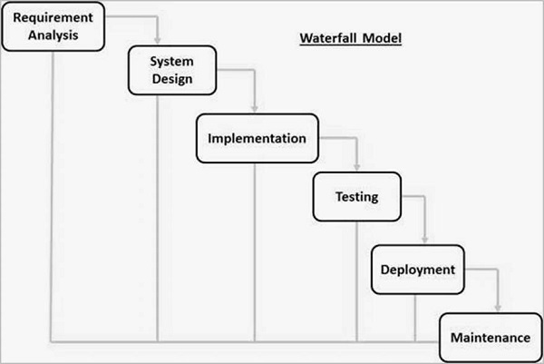

**Waterfall** approach was first SDLC Model to be used widely in Software Engineering to ensure success of the project. In "The Waterfall" approach, the whole process of software development is divided into separate phases. In this Waterfall model, typically, the outcome of one phase acts as the input for the next phase sequentially.

* **The sequential phases in Waterfall model are**
* Requirement Gathering and analysis − All possible requirements of the system to be developed are captured in this phase and documented in a requirement specification document.
* System Design − The requirement specifications from first phase are studied in this phase and the system design is prepared. This system design helps in specifying hardware and system requirements and helps in defining the overall system architecture.
* Implementation − With inputs from the system design, the system is first developed in small programs called units, which are integrated in the next phase. Each unit is developed and tested for its functionality, which is referred to as Unit Testing.
* Integration and Testing − All the units developed in the implementation phase are integrated into a system after testing of each unit. Post integration the entire system is tested for any faults and failures.
* Deployment of system − Once the functional and non-functional testing is done; the product is deployed in the customer environment or released into the market.
* Maintenance − There are some issues which come up in the client environment. To fix those issues, patches are released. Also to enhance the product some better versions are released. Maintenance is done to deliver these changes in the customer environment.
* **Waterfall Model - Application**

Every software developed is different and requires a suitable SDLC approach to be followed based on the internal and external factors. Some situations where the use of Waterfall model is most appropriate are −

* Requirements are very well documented, clear and fixed.
* Product definition is stable.
* Technology is understood and is not dynamic.
* There are no ambiguous requirements.
* Ample resources with required expertise are available to support the product.
* The project is short.

Designing

1. Login form

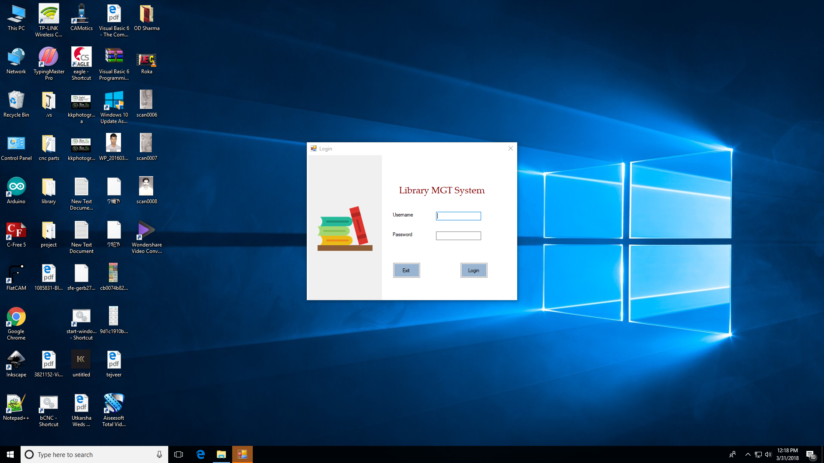 Fig. login form

We are created a login form. This form helps in this application to provide security feature. Because of this feature only those people can access this application they have login id and the password.

In this there are two fields

* User name
* Password

If the user fills the correct information then the application will open.

Else

It can show error message.

You are user name and password is wrong.

1. Welcome message

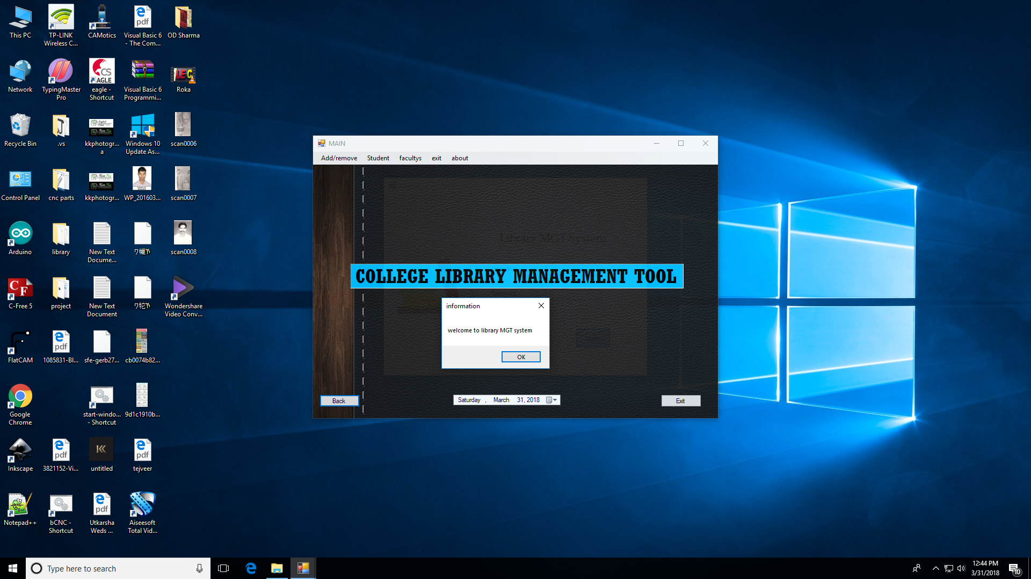Fig. Notification

If the use name and password is correct then it shows a welcome message and a button to press Ok.

After pressing ok button the main form will appears.

1. Main form

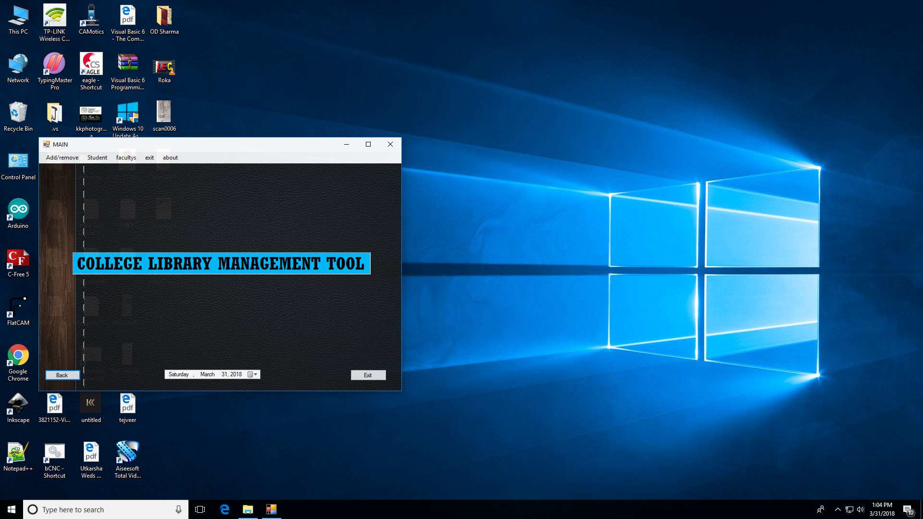

Fig. Main form

Main form is the main hub of this application all the function are available in this form like add and remove books, issue books to students and faculties or time date etc.

This form is resizable we can change it’s size. In this main form there are two buttons

1.Back

2. Exit

Back

Exit

Login form

If we click on back then its open the previous login form and if we click on the exit it will terminate that application.

* 1. Add/remove

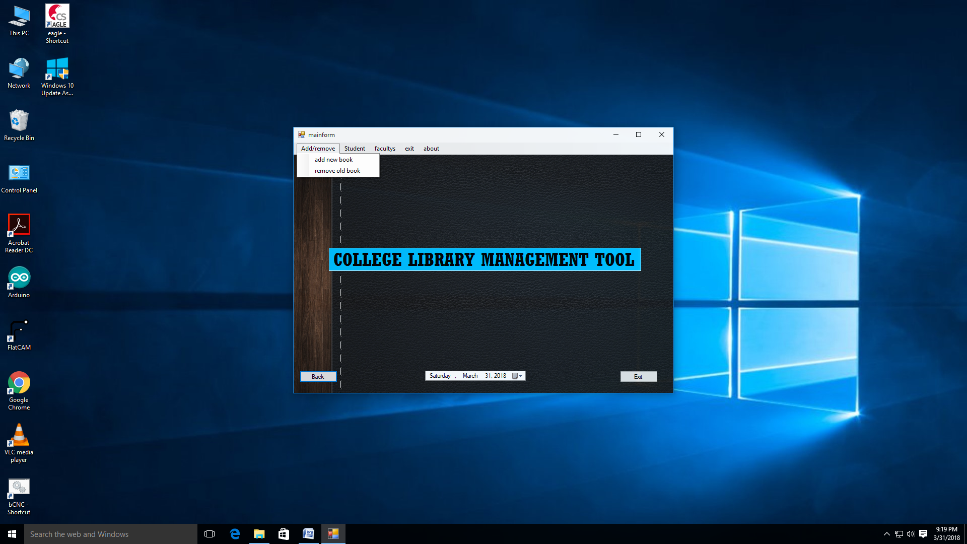

Fig.main form

* Add new book

If we click on add new book then it’s open a new form in this form we can maintain the book record using of this function we can add new books in the library database. The library database is main database that contain all the books record.

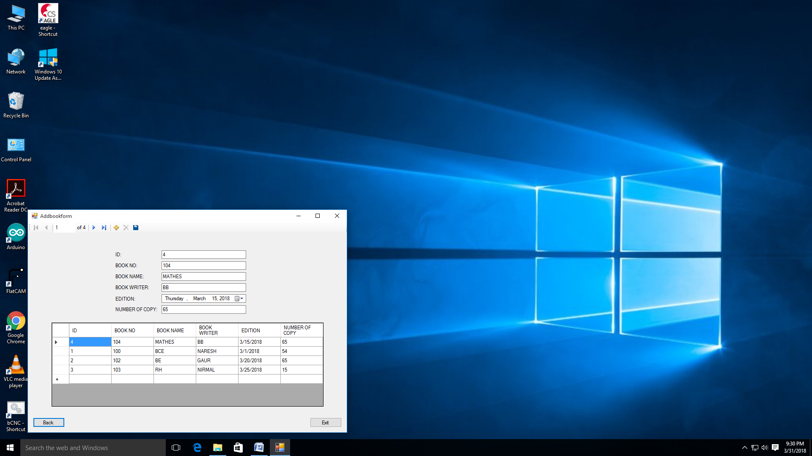

Fig.add new book

Database sheet

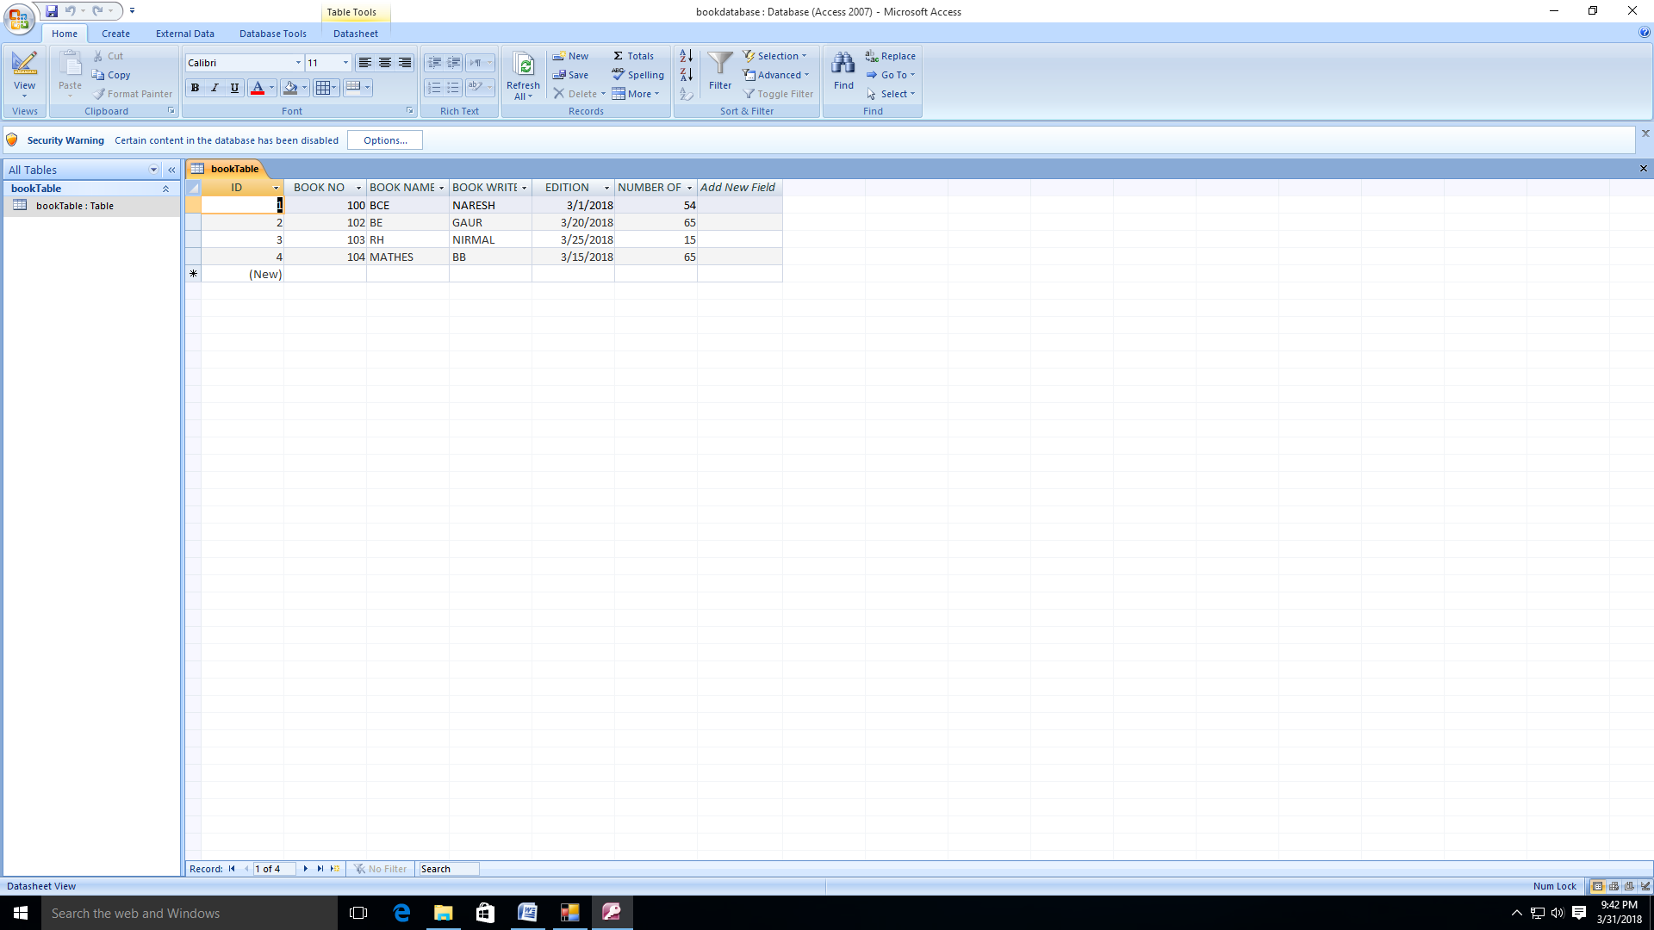

Fig.Book Database

* Remove old book

If we click this function it’s open a new form in this form we can maintain the book record using of this function we can remove old book in the book database. This same database we can use to add new books.

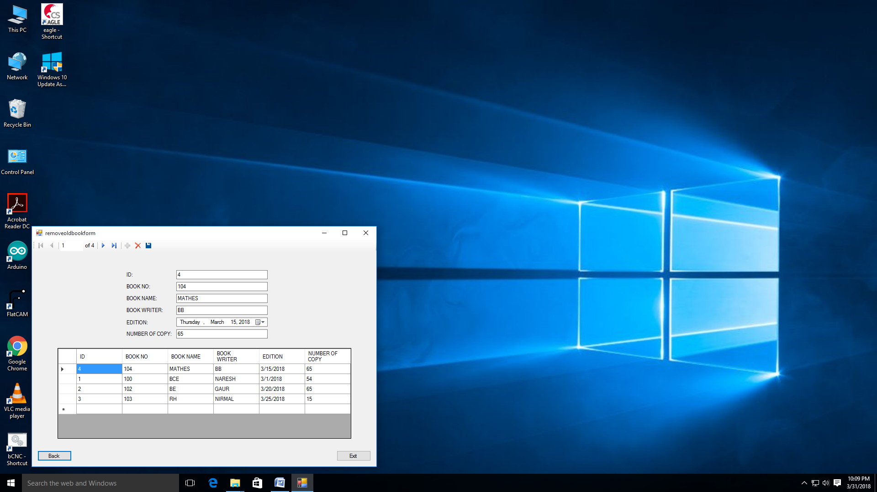

Fig.Remove book from

Database sheet



Fig.Book Database

* 1. Student

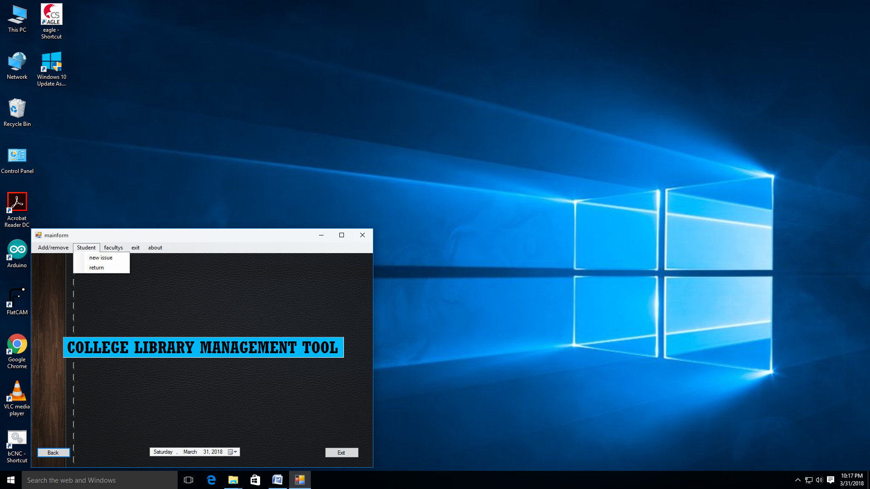

Fig.Student

* New issue

Using of this function we can issue book to student and track the record of books. All the record present in this database are those data that we are issued to student. The all record saves in the database present in this program.

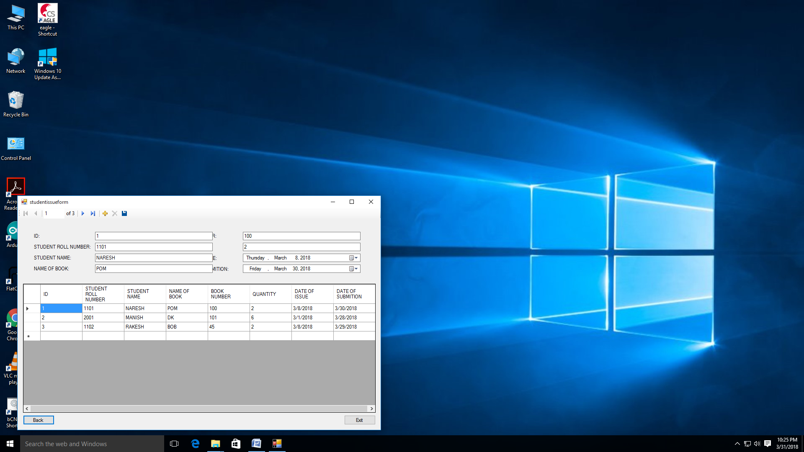

Fig.Student issue form

Database sheet

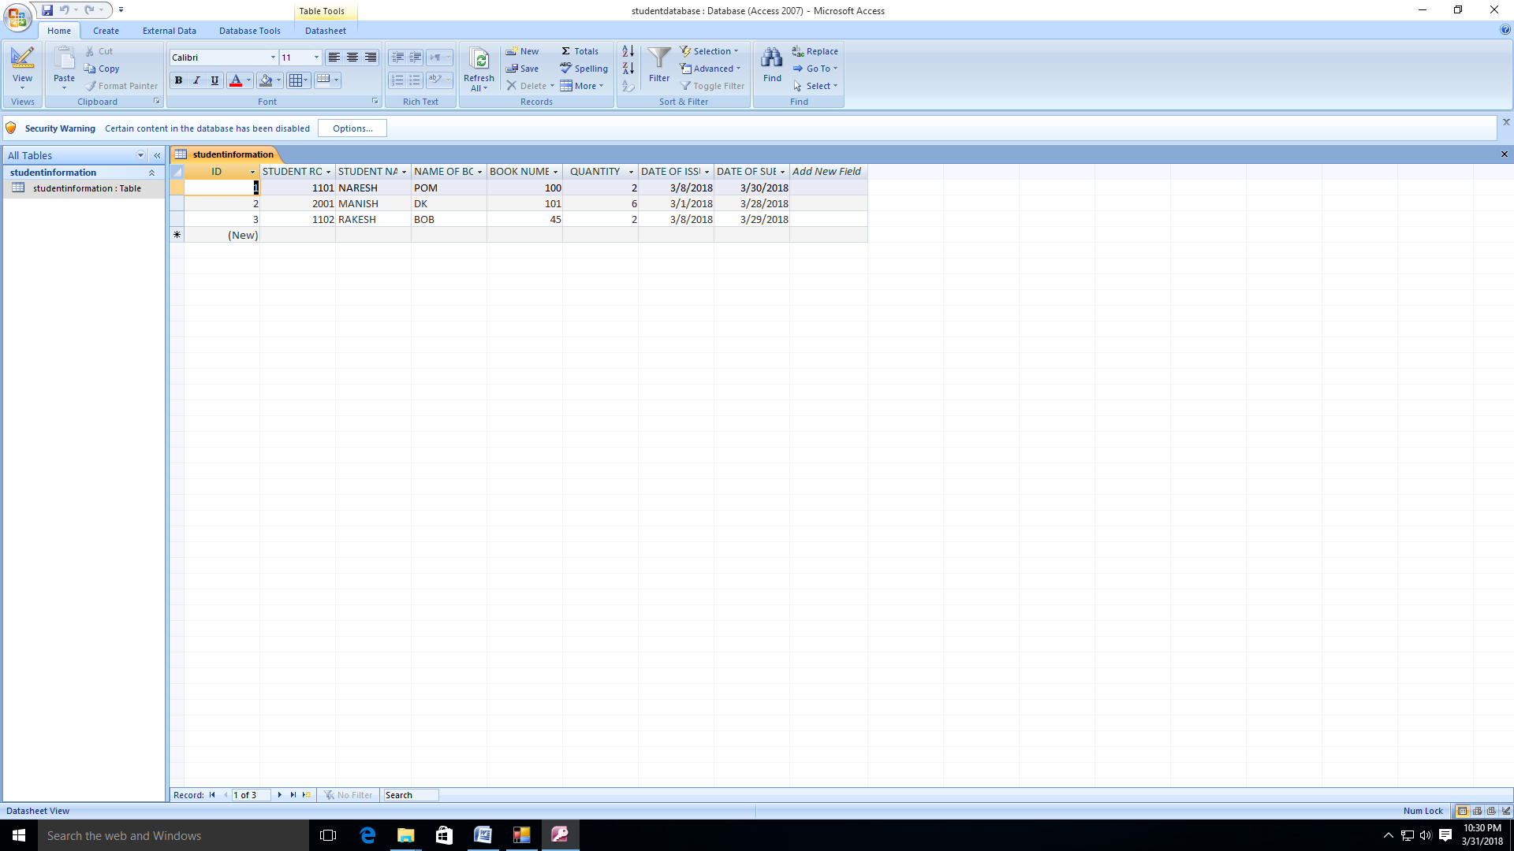

Fig.student database

* Return

Using of this function we can delete those records are present in our Database or return book from library. It use same student database.

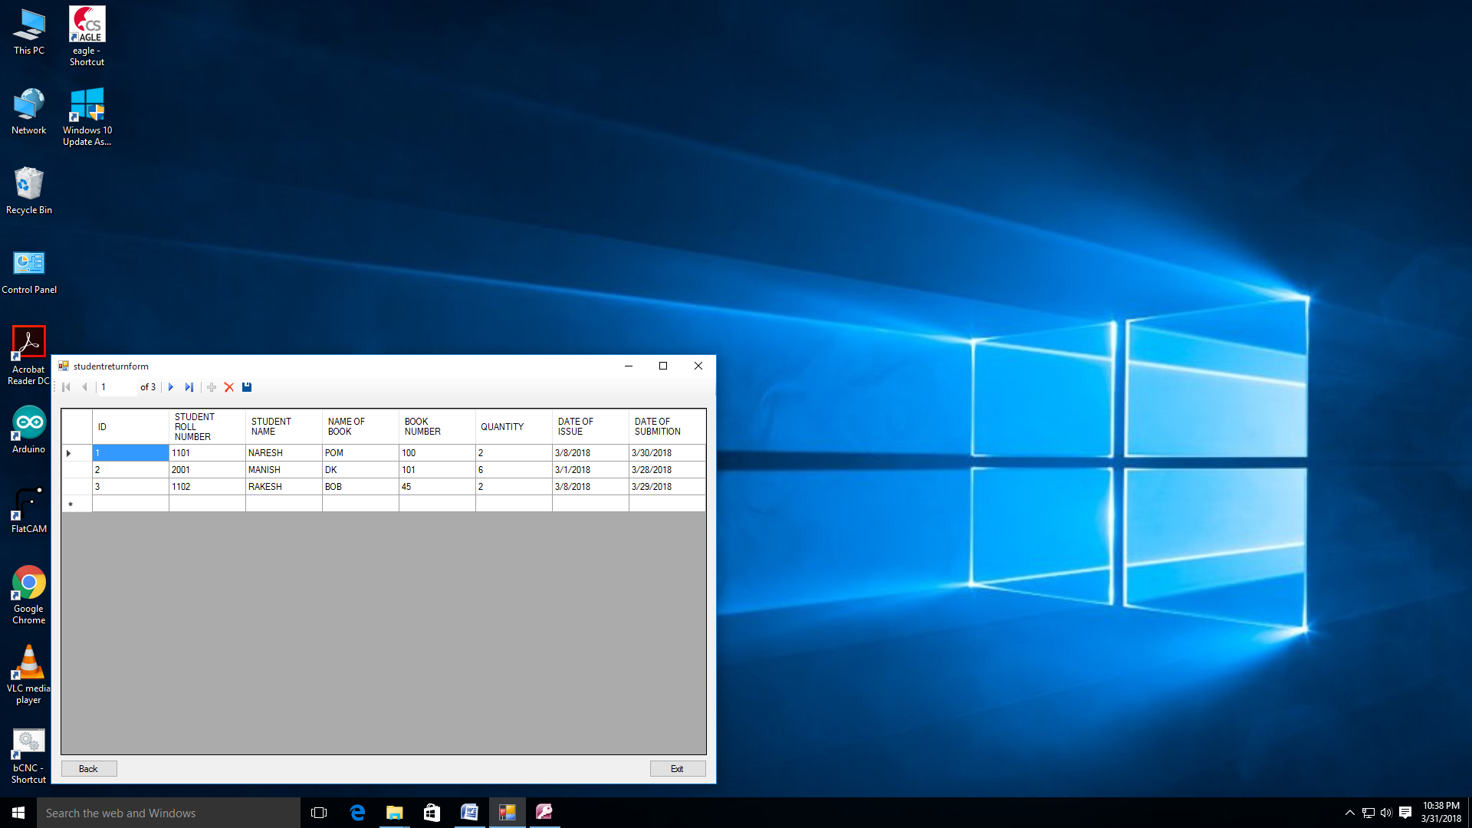

Fig.Student return book form

* 1. Faculties

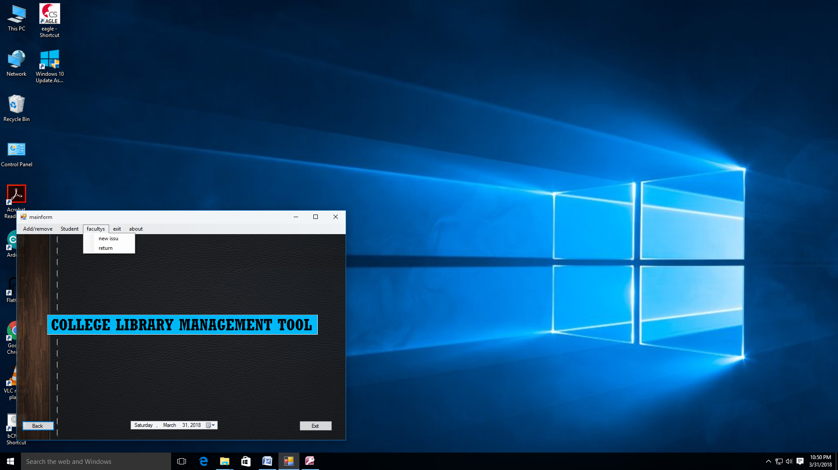

Fig.Main form

* New issue

In this function we can issue book to college staff This is the separate function to issue books to faculties.

Using of this we can track the uses of book each faculty.

It is used a separate database that store faculty records.

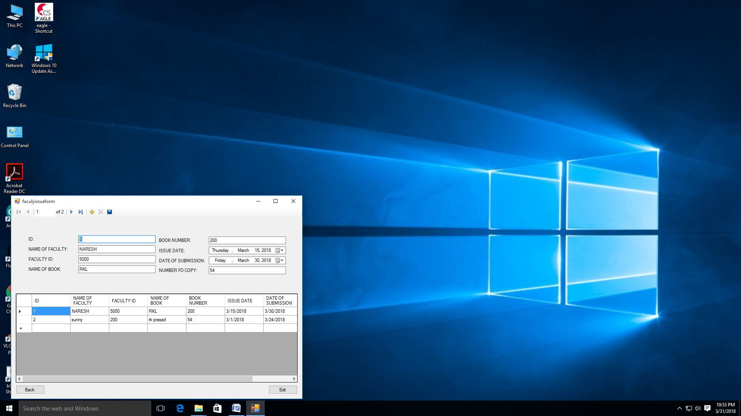

Fig.Faculty issue form

Database sheet

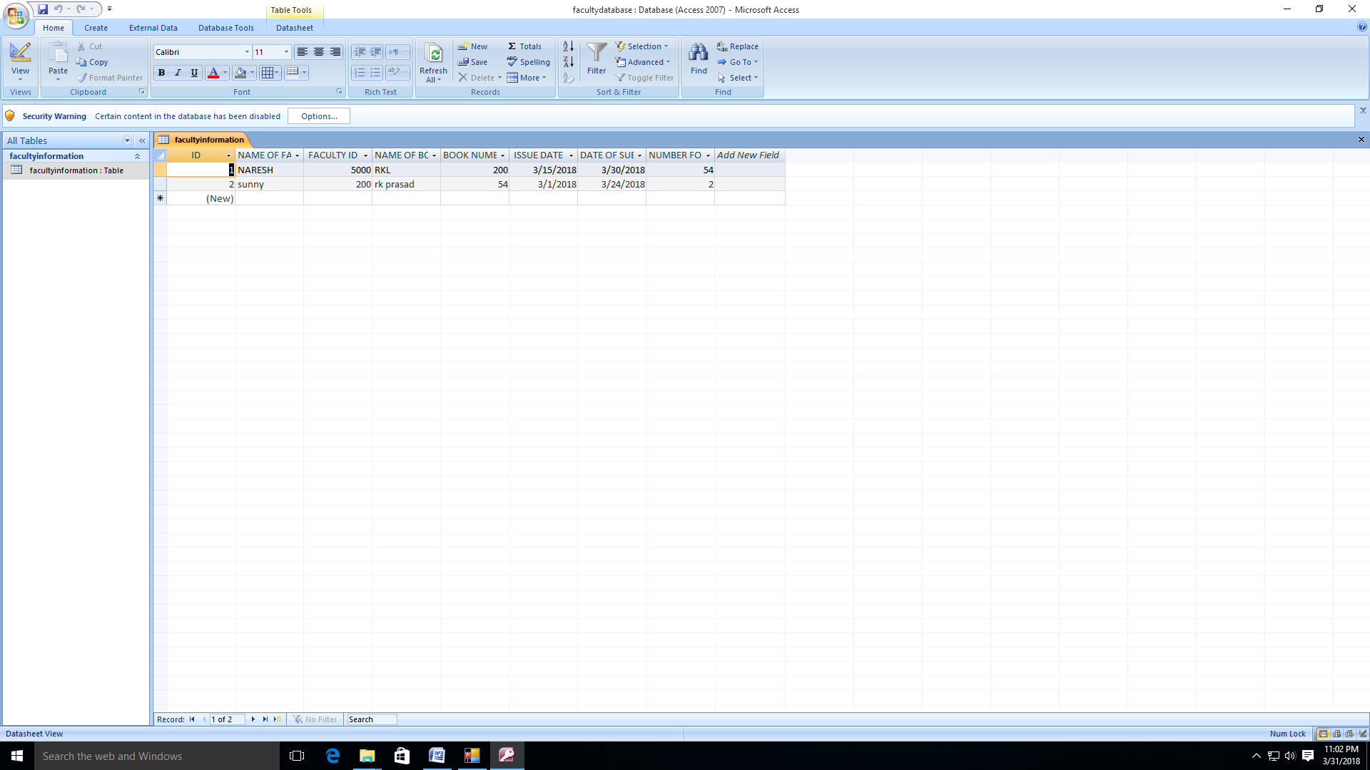

Fig.Faculty database

* Return

Using of this function we can delete those records are present in our Database or return book from library. It use same faculty database.

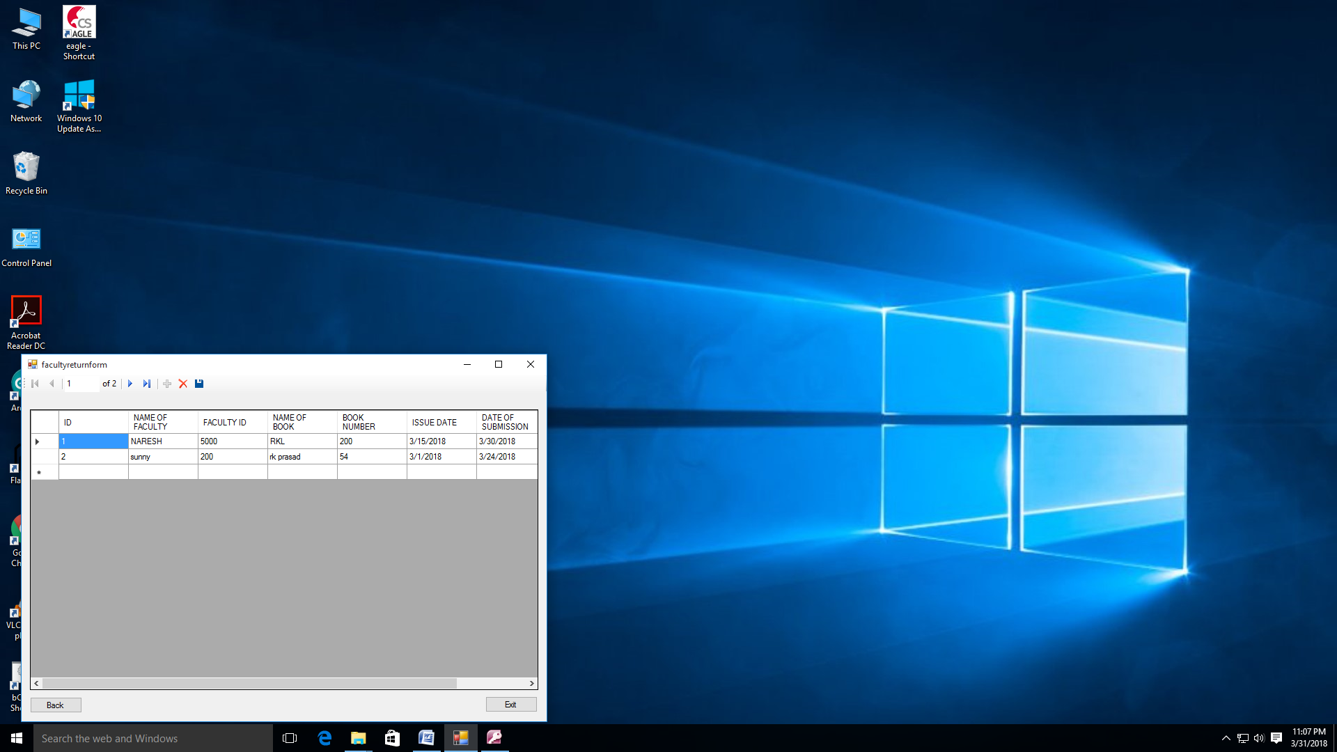

Fig.Faculty return form

* 1. Exit

Click on the exit it will terminate that application.

* 1. About

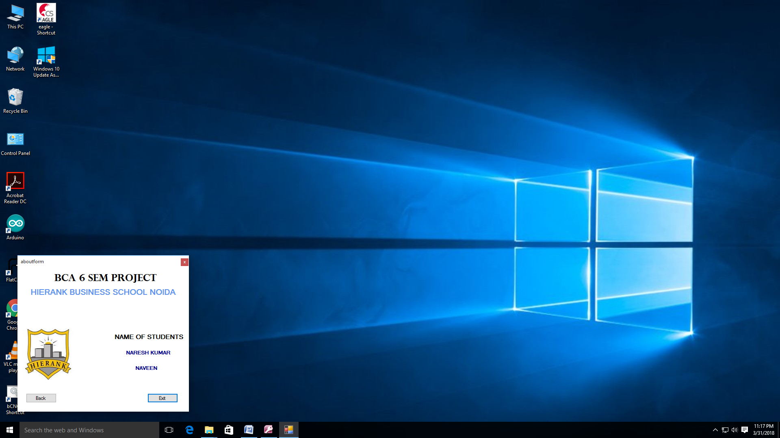

Fig.About

Note:- If you want to change user name and password or add more members then you can add user name and password on usernamepassword database. the default user name and password is naresh ,ng@12345

Testing

Testing is vital for the success of any software. No system design is ever perfect. Testing is also carried in two phases. First phase is during the software engineering that is during the module creation. Second phase is after the completion of software. This is system testing which verifies that the whole set of programs hanged together.

White Box testing

In this technique, the close examinations of the logical parts through the software are tested by cases that exercise species sets of conditions or loops. All logical parts of the software checked once. Errors that can be corrected using this technique are typographical errors, logical expressions which should be executed once may be getting executed more than once and error resulting by using wrong controls and loops. When the box testing tests all the independent part within a module a logical decisions on their true and the false side are exercised, all loops and bounds within their operational bounds were exercised and internal data structure to ensure their validity were exercised once.

Black box testing

This method enables the software engineer to device sets of input techniques that fully exercise all functional requirements for a program. Black box testing tests the input the output and the external data. It checks whether the input data is correct and whether we are getting the desired output.

Alpha Testing

Acceptance testing is also sometimes called alpha testing. Be spoke systems are developed for a single customer. The alpha testing proceeds until the system developer and the customer agree that the provided system is an acceptable implementation of the system requirements.

Beta Testing

On the other hand, when a system is to be marked as a software product, another process called beta testing is often conducted, during beta testing; a system is delivered among a number of potential users who agree to use it. The customers then report problems to the developers. This provides the product for real use and detects errors which may not have been anticipated by the system developers.

Unit testing

Test smallest testable parts of an application, called units, are individually and independently scrutinized for proper operation.

Integration Testing

Integration testing is the phase in software testing in which individual software modules are combined and tested as a group.  
System integration testing (SIT) is a high-level software testing process in which testers verify that all related systems maintain data integrity and can operate in coordination with other systems in the same environment.

Validation testing

Validation testing was performed to ensure that all the functional and performance requirements are met.

System testing

It is executing programs to check logical changes made in it with intention of finding errors. A system is tested for online response, volume of transaction, recovery from failure etc. system testing is done to ensure that the system satisfies all the user requirements.

Screen short

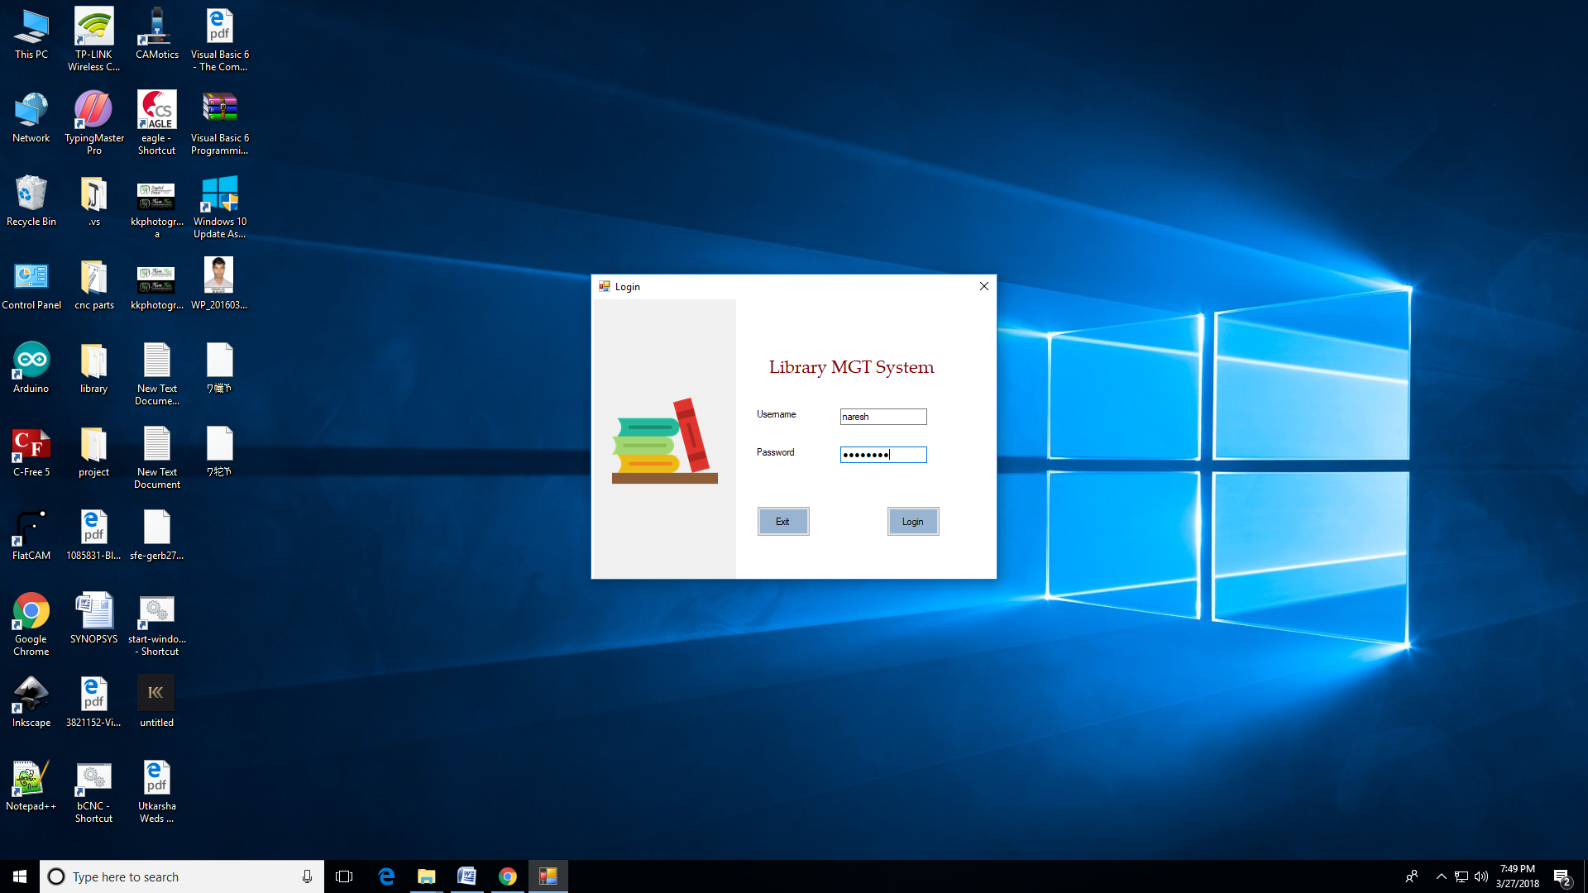

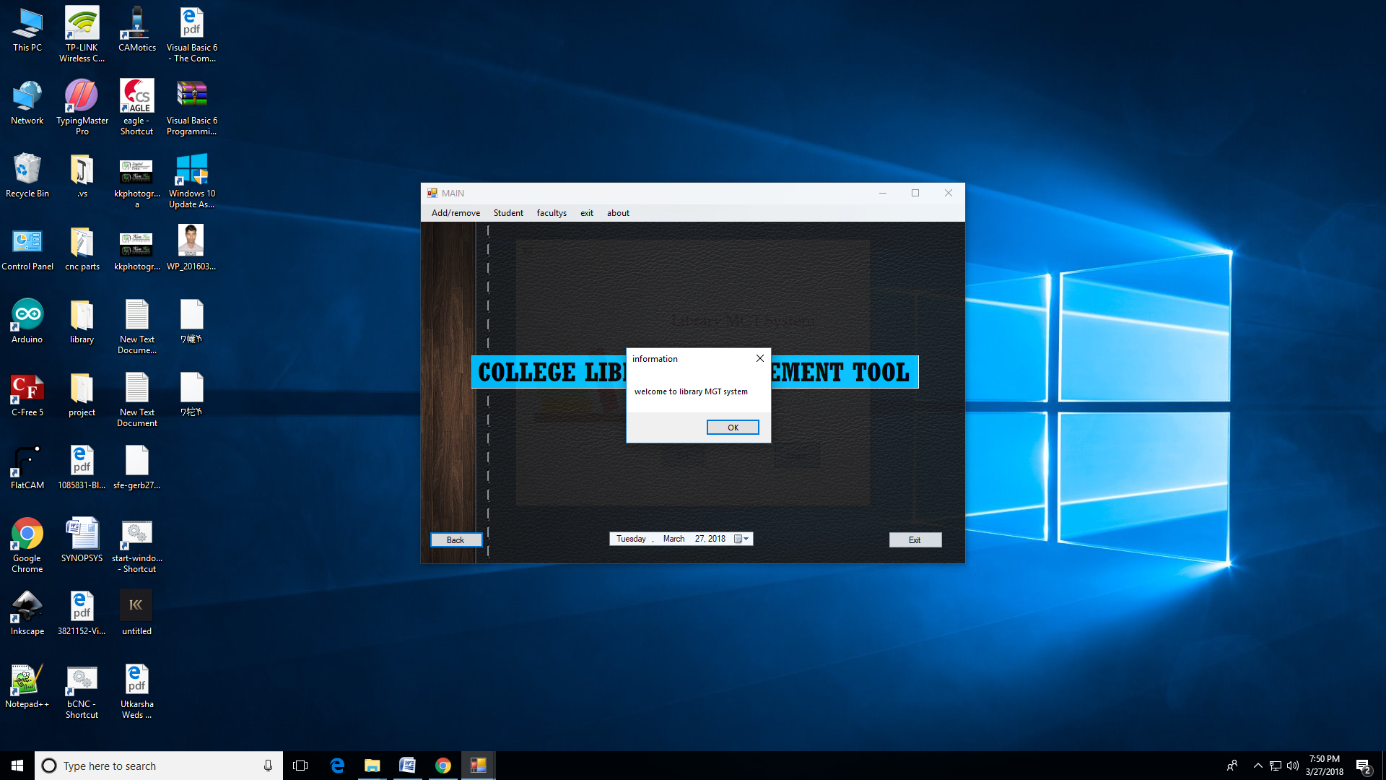

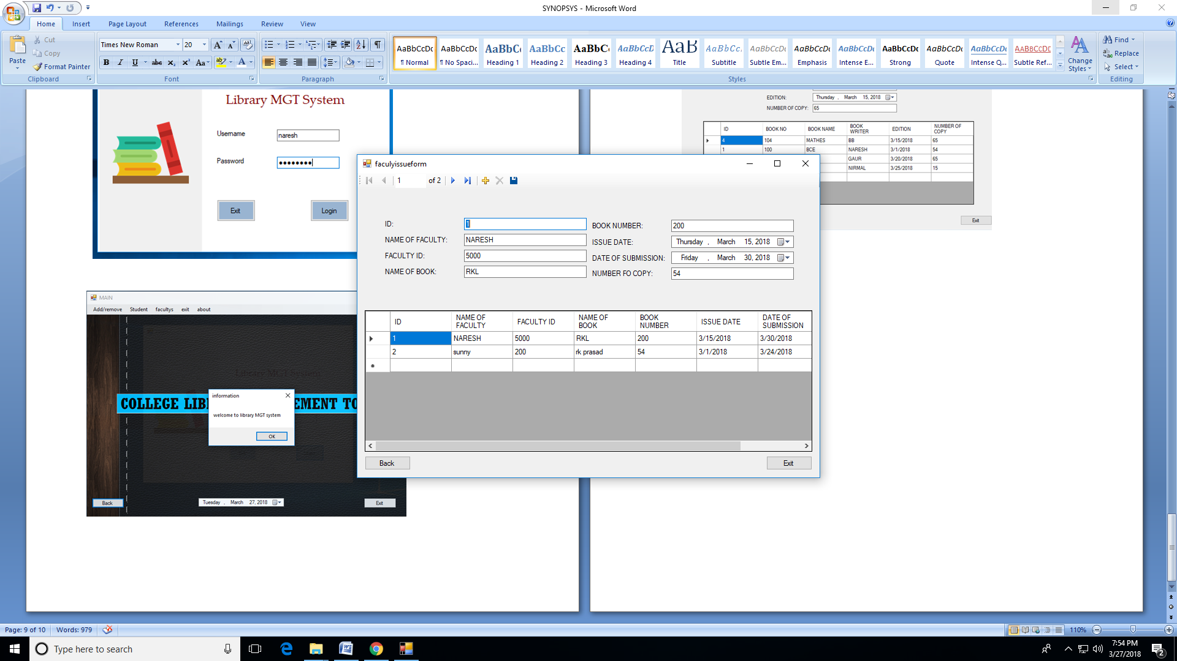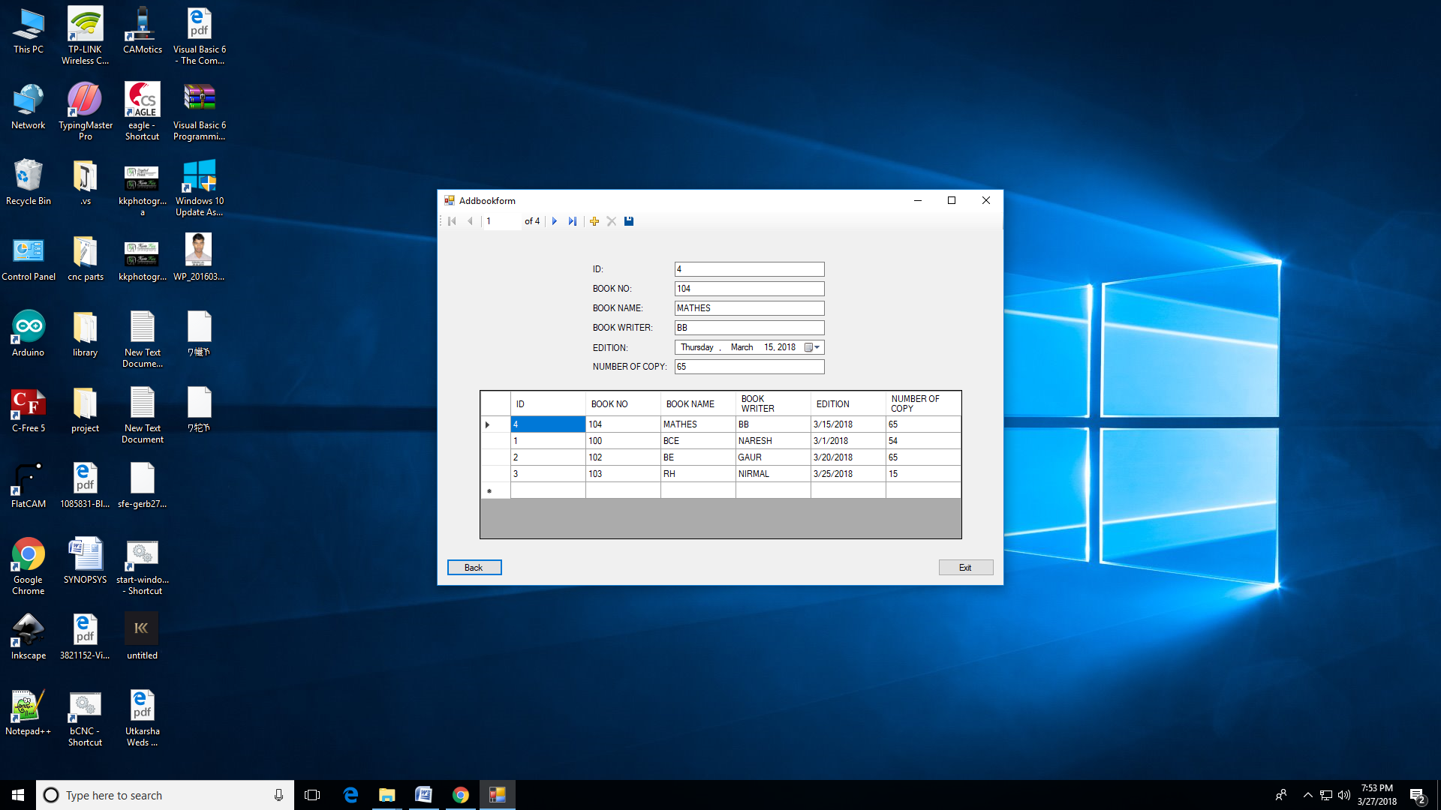

Reference









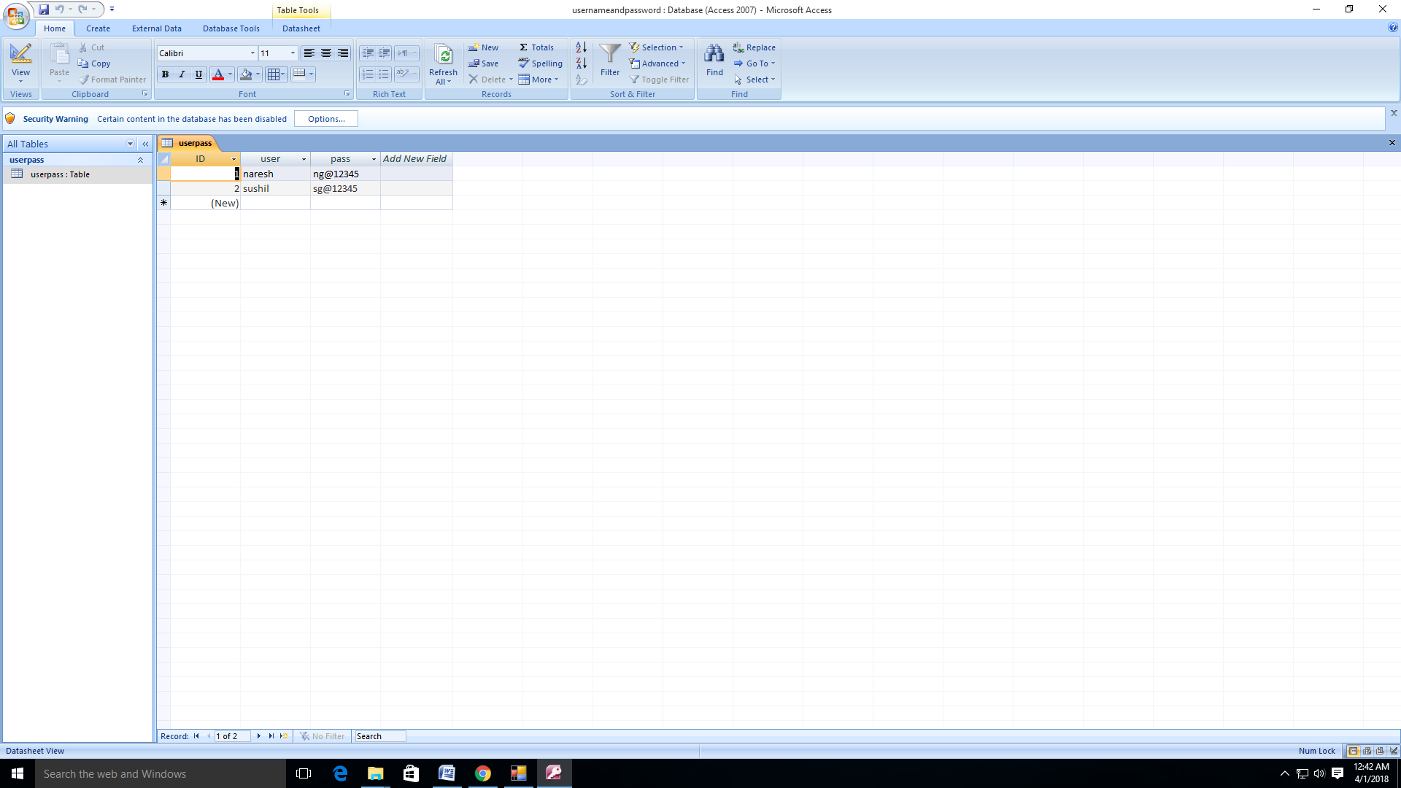

Source code

Login form:-

Public Class Form1

Private Sub Button1_Click(sender As Object, e As EventArgs) Handles Button1.Click

Dim username As String

Dim password As String

Dim message As String = "your usernsme & password is wrong"

username = TextBox1.Text

password = TextBox2.Text

If Me.UserpassTableAdapter.ScalarQueryLogin1(username, password) Then

mainform.Show()

TextBox1.Clear()

TextBox2.Text = ""

MessageBox.Show("welcome to library MGT system", "information", MessageBoxButtons.OK)

Me.Hide()

Else

MessageBox.Show(message, "information", MessageBoxButtons.OK)

TextBox1.Clear()

TextBox2.Text = ""

End If

End Sub

Private Sub UserpassBindingNavigatorSaveItem_Click(sender As Object, e As EventArgs) Handles UserpassBindingNavigatorSaveItem.Click

Me.Validate()

Me.UserpassBindingSource.EndEdit()

Me.TableAdapterManager.UpdateAll(Me.UsernameandpasswordDataSet)

End Sub

Private Sub Form1_Load(sender As Object, e As EventArgs) Handles MyBase.Load

'TODO: This line of code loads data into the 'UsernameandpasswordDataSet.userpass' table. You can move, or remove it, as needed.

Me.UserpassTableAdapter.Fill(Me.UsernameandpasswordDataSet.userpass)

End Sub

Private Sub Button2_Click(sender As Object, e As EventArgs) Handles Button2.Click

Me.Close()

End

End Sub

Private Sub Panel1_Paint(sender As Object, e As PaintEventArgs) Handles Panel1.Paint

End Sub

Private Sub Label3_Click(sender As Object, e As EventArgs) Handles Label3.Click

End Sub

Private Sub TextBox1_TextChanged(sender As Object, e As EventArgs) Handles TextBox1.TextChanged

End Sub

End Class

Main form:-

Public Class mainform

Private Sub Button1_Click(sender As Object, e As EventArgs) Handles Button1.Click

Me.Hide()

Form1.Show()

End Sub

Private Sub Button2_Click(sender As Object, e As EventArgs) Handles Button2.Click

Me.Close()

End

End Sub

Private Sub NewbookToolStripMenuItem_Click(sender As Object, e As EventArgs) Handles NewbookToolStripMenuItem.Click

'add book

Addbookform.Show()

Me.Hide()

End Sub

Private Sub OldbookToolStripMenuItem_Click(sender As Object, e As EventArgs) Handles OldbookToolStripMenuItem.Click

'remove book

removeoldbookform.Show()

Me.Hide()

End Sub

Private Sub ExitToolStripMenuItem1_Click(sender As Object, e As EventArgs) Handles ExitToolStripMenuItem1.Click

Me.Close()

End

End Sub

Private Sub NewIssuToolStripMenuItem_Click(sender As Object, e As EventArgs) Handles NewIssuToolStripMenuItem.Click

'new student issue

studentissueform.Show()

Me.Hide()

End Sub

Private Sub mainform_Load(sender As Object, e As EventArgs) Handles MyBase.Load

End Sub

Private Sub FacultysToolStripMenuItem_Click(sender As Object, e As EventArgs) Handles FacultysToolStripMenuItem.Click

End Sub

Private Sub ReturnToolStripMenuItem1_Click(sender As Object, e As EventArgs) Handles ReturnToolStripMenuItem1.Click

'faculty return book

facultyreturnform.Show()

Me.Hide()

End Sub

Private Sub ReturnToolStripMenuItem_Click(sender As Object, e As EventArgs) Handles ReturnToolStripMenuItem.Click

'return student

studentreturnform.Show()

Me.Hide()

End Sub

Private Sub NewIssuToolStripMenuItem1_Click(sender As Object, e As EventArgs) Handles NewIssuToolStripMenuItem1.Click

'faculty issue book

faculyissueform.Show()

Me.Hide()

End Sub

Private Sub AboutToolStripMenuItem_Click(sender As Object, e As EventArgs) Handles AboutToolStripMenuItem.Click

aboutform.Show()

Me.Hide()

End Sub

End Class

Add book form:-

Public Class Addbookform

Private Sub Button1_Click(sender As Object, e As EventArgs) Handles Button1.Click

mainform.Show()

Me.Close()

End Sub

Private Sub BookTableBindingNavigatorSaveItem_Click(sender As Object, e As EventArgs) Handles BookTableBindingNavigatorSaveItem.Click

Me.Validate()

Me.BookTableBindingSource.EndEdit()

Me.TableAdapterManager.UpdateAll(Me.BookdatabaseDataSet)

End Sub

Private Sub Addbookform_Load(sender As Object, e As EventArgs) Handles MyBase.Load

'TODO: This line of code loads data into the 'BookdatabaseDataSet.bookTable' table. You can move, or remove it, as needed.

Me.BookTableTableAdapter.Fill(Me.BookdatabaseDataSet.bookTable)

End Sub

Private Sub Button2_Click(sender As Object, e As EventArgs) Handles Button2.Click

Me.Close()

End

End Sub

End Class

Remove book form:-

Public Class removeoldbookform

Private Sub Button1_Click(sender As Object, e As EventArgs) Handles Button1.Click

mainform.Show()

Me.Close()

End Sub

Private Sub BookTableBindingNavigatorSaveItem_Click(sender As Object, e As EventArgs) Handles BookTableBindingNavigatorSaveItem.Click

Me.Validate()

Me.BookTableBindingSource.EndEdit()

Me.TableAdapterManager.UpdateAll(Me.BookdatabaseDataSet)

End Sub

Private Sub removeoldbookform_Load(sender As Object, e As EventArgs) Handles MyBase.Load

'TODO: This line of code loads data into the 'BookdatabaseDataSet.bookTable' table. You can move, or remove it, as needed.

Me.BookTableTableAdapter.Fill(Me.BookdatabaseDataSet.bookTable)

End Sub

Private Sub Button2_Click(sender As Object, e As EventArgs) Handles Button2.Click

Me.Close()

End

End Sub

End Class

Student book issue form:-

Private Sub Button1_Click(sender As Object, e As EventArgs) Handles Button1.Click

mainform.Show()

Me.Close()

End Sub

Private Sub Button2_Click(sender As Object, e As EventArgs) Handles Button2.Click

Me.Close()

End

End Sub

Private Sub studentissueform_Load(sender As Object, e As EventArgs) Handles MyBase.Load

'TODO: This line of code loads data into the 'StudentdatabaseDataSet.studentinformation' table. You can move, or remove it, as needed.

Me.StudentinformationTableAdapter.Fill(Me.StudentdatabaseDataSet.studentinformation)

'TODO: This line of code loads data into the 'BookdatabaseDataSet.bookTable' table. You can move, or remove it, as needed.

'Me.BookTableTableAdapter.Fill(Me.BookdatabaseDataSet.bookTable)

'TODO: This line of code loads data into the 'StudentdatabaseDataSet.studentinformation' table. You can move, or remove it, as needed.

Me.StudentinformationTableAdapter.Fill(Me.StudentdatabaseDataSet.studentinformation)

'TODO: This line of code loads data into the 'BookdatabaseDataSet.bookTable' table. You can move, or remove it, as needed.

'Me.BookTableTableAdapter.Fill(Me.BookdatabaseDataSet.bookTable)

End Sub

Private Sub StudentinformationBindingNavigatorSaveItem_Click(sender As Object, e As EventArgs) Handles StudentinformationBindingNavigatorSaveItem.Click

Me.Validate()

Me.StudentinformationBindingSource.EndEdit()

Me.TableAdapterManager.UpdateAll(Me.StudentdatabaseDataSet)

End Sub

End Class

Student book return form:-

Public Class studentreturnform

Private Sub StudentinformationBindingNavigatorSaveItem_Click(sender As Object, e As EventArgs) Handles StudentinformationBindingNavigatorSaveItem.Click

Me.Validate()

Me.StudentinformationBindingSource.EndEdit()

Me.TableAdapterManager.UpdateAll(Me.StudentdatabaseDataSet)

End Sub

Private Sub studentreturnform_Load(sender As Object, e As EventArgs) Handles MyBase.Load

'TODO: This line of code loads data into the 'StudentdatabaseDataSet.studentinformation' table. You can move, or remove it, as needed.

Me.StudentinformationTableAdapter.Fill(Me.StudentdatabaseDataSet.studentinformation)

End Sub

Private Sub Button1_Click(sender As Object, e As EventArgs) Handles Button1.Click

mainform.Show()

Me.Close()

End Sub

Private Sub Button2_Click(sender As Object, e As EventArgs) Handles Button2.Click

Me.Close()

End

End Sub

End Class

Faculty’s book issue form:-

ublic Class faculyissueform

Private Sub FacultyinformationBindingNavigatorSaveItem_Click(sender As Object, e As EventArgs) Handles FacultyinformationBindingNavigatorSaveItem.Click

Me.Validate()

Me.FacultyinformationBindingSource.EndEdit()

Me.TableAdapterManager.UpdateAll(Me.FacultydatabaseDataSet)

End Sub

Private Sub faculyissueform_Load(sender As Object, e As EventArgs) Handles MyBase.Load

'TODO: This line of code loads data into the 'FacultydatabaseDataSet.facultyinformation' table. You can move, or remove it, as needed.

Me.FacultyinformationTableAdapter.Fill(Me.FacultydatabaseDataSet.facultyinformation)

End Sub

Private Sub Button1_Click(sender As Object, e As EventArgs) Handles Button1.Click

mainform.Show()

Me.Close()

End Sub

Private Sub Button2_Click(sender As Object, e As EventArgs) Handles Button2.Click

Me.Close()

End

End Sub

End Class

Faculty’s book return form:-

ublic Class facultyreturnform

Private Sub FacultyinformationBindingNavigatorSaveItem_Click(sender As Object, e As EventArgs) Handles FacultyinformationBindingNavigatorSaveItem.Click

Me.Validate()

Me.FacultyinformationBindingSource.EndEdit()

Me.TableAdapterManager.UpdateAll(Me.FacultydatabaseDataSet)

End Sub

Private Sub facultyreturnform_Load(sender As Object, e As EventArgs) Handles MyBase.Load

'TODO: This line of code loads data into the 'FacultydatabaseDataSet.facultyinformation' table. You can move, or remove it, as needed.

Me.FacultyinformationTableAdapter.Fill(Me.FacultydatabaseDataSet.facultyinformation)

End Sub

Private Sub Button1_Click(sender As Object, e As EventArgs) Handles Button1.Click

mainform.Show()

Me.Close()

End Sub

Private Sub Button2_Click(sender As Object, e As EventArgs) Handles Button2.Click

Me.Close()

End

End Sub

End Class

Exit function:-

Private Sub ExitToolStripMenuItem1_Click(sender As Object, e As EventArgs) Handles ExitToolStripMenuItem1.Click

Me.Close()

End

End Sub

About form:-

Public Class aboutform

Private Sub Button1_Click(sender As Object, e As EventArgs) Handles Button1.Click

Me.Close()

End

End Sub

Private Sub Button2_Click(sender As Object, e As EventArgs) Handles Button2.Click

mainform.Show()

Me.Hide()

End Sub

End Class

Conclusion

The author had successfully completed the objective and study the information about the author's Library Management System (LMS). The author also learned that the knowledge about the functions of the system. Each category of user has its own functional. So in order to make the author's Library Management System much better, study on the existing system for LMS is needed so it can improve the author's Library Management System.

Future scope of the projet

In a nutshell, it can be summarized that the future scope of the profect circles around maintaining information regarding:

* We can add printer in futue.
* We can give more advance software for Library Managenent System including more facilities
* We will host the platform on online servers to make it accessible worldwide
* Integrate multiple load balancers to distribute the loads of the system
* Create the master and slave database structute to reduce the overload of the database queries
* Implement the backup mechanism for taking bakup of codebase and database on regular basis on different srevers

The above mentioned points are the enhancements which can be done to increase the applicability and usage of this project. Here we can maintain the records of student and books. Also, as it can be seen that now a days the players are versatile, i.e. so there is a scope for introducing a method to maintain the library management system. Enhancements can be done to maintain all the student, books, lssues, librarian, menber.

We have left all the options open so that if there is any other future requirement in the system by the user for the enhancement of the system then it is posssible to implement them. In the last we would like to thanks all the persons involved in the development of the system directly or indirectly. We hope that the profect will serve its purpose for which it is develop there by underlining success of process.

Biblography

<https://www.youtube.com/watch?v=IShHHzwaNz8>

<https://www.youtube.com/watch?v=XRVBpTFa3To>

<https://www.youtube.com/watch?v=MXnFTlv3rlQ>

visual basic black book